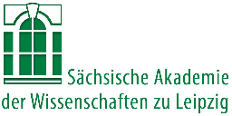
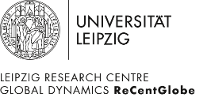
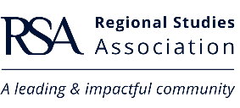
RSA Central and Eastern Europe (CEE) Conference 2022
Bridging Old and New Divides:
Global Dynamics, Regional transformations
13th – 17th September 2022
Research Centre Global Dynamics, Leipzig University, Germany and Online

Special Session Proposal submission deadline: 21st March 2022
CALL FOR SPECIAL SESSION PROPOSALS

As part of the 2022 Central and Eastern Europe (CEE) Conference, we welcome proposals for Special Sessions. Special Sessions are a great way to bring together presenters to discuss and highlight a particular topic and to develop or further extend your network.

We offer two types of Special Sessions:
- Open Special Session – the session organiser proposes the topic and provides a short description/call for submissions (please use headers below). Delegates can submit their abstract for this session when they register for the conference.

- Closed Special Session – the session organiser proposes the complete session including all speakers. Other delegates may not submit their abstracts for this session. Please note that all speakers need to register to be able to present.

Both special session types are open to all delegates to attend as audience. Sessions are scheduled to be 90 minutes long.

Once your Special Session proposal has been accepted, we will add it to the conference webpage and promote it. As the session organiser, we would be grateful if you could also spread the word to interested researchers via your networks.

After the general abstract submission deadline has closed, you will receive all abstracts submitted to your special session for your review.

After reviewing the abstracts, the next step will be to send the accepted abstracts in the order you wish to have them in your Special Session to the RSA. The actual scheduling of the programme will then be done by the RSA.

Contact:

If you would like to organise a Special Session, please complete the headings below and send to Katharina Bürger at katharina.buerger@regionalstudies.org.

Special Session Title: Click or tap here to enter text.

Special Session Organiser(s), incl. institution and country:
- Click or tap here to enter text.
- Click or tap here to enter text.
- Click or tap here to enter text.
- Click or tap here to enter text.
- Click or tap here to enter text.
Further organisers: Click or tap here to enter text.

Twitter handles and hashtags used by the session organiser(s):
Click or tap here to enter text.

Open/Closed Special Session: Click or tap here to enter text.

Description (with speakers listed if a closed special session): Click or tap here to enter text.

