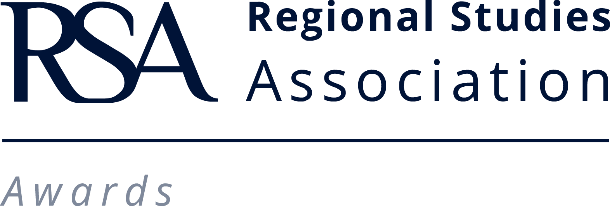

RSA & ROUTLEDGE EARLY CAREER AWARD 2021
Call for Nominations
Nominations (both self-nominations and third-party nominations) of current members are being sought for the following awards in regional studies and related fields:
- Nathaniel Lichfield Award – this award is for recent Masters graduate who has graduated within the previous year;
- Paul Benneworth PhD Student Award – this award is for registered PhD students who have not yet received their certificate;
- RSA Routledge Early Career Award – this award is for early career researchers defined as being within five years of the date on their PhD certificate or equivalent.
The nominees are expected to have made an original and outstanding contribution to the field of regional studies. To be eligible for nomination, the recipient should be clearly identified as having made a leading personal contribution.

The prize for each Award* is:
- A cheque for £500;
- A certificate.
Nominations should include a fully referenced piece of work in English, which fits the research interests of the Association.

Submissions are particularly welcome in our prioritised fields of research:
- Regional theory
- Regional economic development
- Regional planning and policy
- Regional policy, public management and policy evaluation
- Territorial politics, governance, regionalism and federalism
- Regional ‘impacts’
- Data, methods and spatial econometrics
- Regional identities

Forthcoming Deadline: 30 April 2021

*In the case the award is assigned to two or more nominees, the prize will be divided equally among the winners.

RSA & ROUTLEDGE EARLY CAREER AWARD 2021
Nomination / Application Form

Deadline for submissions for next round: 30 April 2021

The nominee (early career researcher defined as being within five years of the date on his/her PhD certificate or equivalent) is expected to have made an original and outstanding contribution to the field of regional studies and the leading personal contribution of the recipient to the work must be clearly identifiable. Nominations should include a fully referenced piece of work in English, which fits the research interests of the Association.

The nominator must fill in the application form below giving their contact details and the reasons for nominating the individual. Please submit the nomination and a fully referenced piece of work in English via email to: Klara Sobekova at Klara.Sobekova@regionalstudies.org

Is this a self-nomination form?  If you are self-nominating, please suggest someone who would act as an academic referee in the table below. | Yes - No
Are you a member of the Association?  Please note that either the nominee or the nominator has to be a current RSA member. If the nominee is selected to receive an award, he/she will need to have an active RSA membership. | Yes - No
RSA Membership ID number
You can find your membership number by logging into Members Lounge and clicking on Member’s Details.

I. NOMINATOR / ACADEMIC REFEREE
Please specify | Nominator - Academic referee
Full name and title
Department
Institution
Address
Email address
Phone number

II. CANDIDATE / NOMINEE
Full name and title
Department
Institution
Address
Course title
Graduation date (date on the PhD certificate)
Email address
Phone number
Title of paper (please attach to this nomination)

III. Please provide us with your reasons for this nomination.

IV. How does the nominee’s work meet the aims of the Regional Studies Association?

V. Signature of person completing form and date.

Name:

Date:

Please attach a copy of the work of the candidate you wish to nominate/if you are self-nominating. The nomination will not be valid if a copy of the work is not made available to the RSA.

