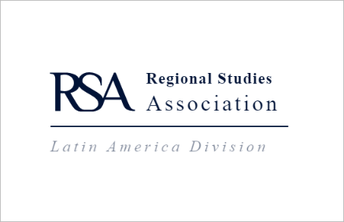
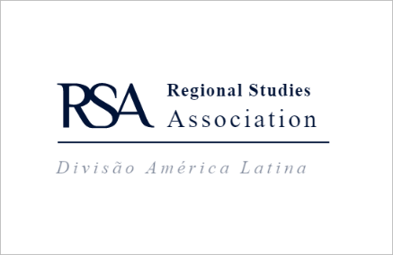
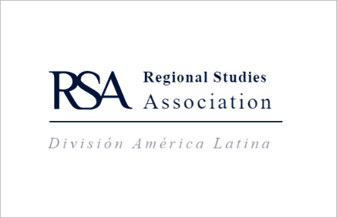

Minutes of the
Third Annual General Meeting of
THE REGIONAL STUDIES ASSOCIATION LATIN AMERICA DIVISION
held by Zoom on 5 November 2020 beginning at 9am Bogota time

Attendees: Sergio Montero, Jose Borello, Renato Garcia, Alejandro Mercado Celis, Paula Bastos, Alejandra Trejo, Pedro Amaral, Jana Schmutzler de Uribe, Igor Tupy

RSA representatives: Sally Hardy, Suede Stanton-Drudy

Item 1: Minutes of the meeting held on 28th January 2019
The meeting approved the minutes.

Item 2: Actions from Previous Meeting
- Actions in relation to the 2020 Division conference – all deferred.
- Miguel to be the Area Development and Policy LA special issue Editor, with Bernardo, Alejandra and Alejandro assisting. Topics to be confirmed: one possibility is new approaches from the Global South. – Alejandra to contact Miguel and report back to the Division
- All Ambassadors to send databases to Jose to create a central LA database of contacts listing key scholars, institutions and conference delegates. Jose to resend to Suede the previously created database of contact details - all Ambassadors to send contact details to Jose.
- Miguel to collate contact details of people in the field in Chile and send to Jose. - outstanding
- All LA representatives to write a short piece (one page long) on an LA issue for the Regions e-Zine in order to maintain a Latin American presence in the magazine. Bernardo, Paula and Miguel to write pieces focusing on environmental issues in Latin America - outstanding, Jose to contact the Editor of Regions regarding this.
- Attendees to write blogs to support the Regions articles to raise awareness of LA research and regional/urban development/policy, to promote the LA Division and its conference - encompassed above.
- Daniela to research any funding opportunities for a writing workshop, Igor to try to source some funding from Young Scholar’s Initiative – Igor to investigate partnering to achieve this. Further suggestions to assists students were a workshop for the Latin America Division hosted by ADP on how to write for the journal; forming an Early Careers group that would meet regularly; and a webinar series for PhDs and Early Careers focusing on writing, with Ambassadors presenting from time to time.
Action: Sally Hardy to follow up with ADP.
Action: Sergio to organise an EC group.
Action: Alejandra to coordinate webinar series.
Item 3: Report to the Board of Territorial Activities

- RSA Latin America Division – Sergio Montero
Sergio reported that as there was no annual LA Division event this year the main focus of the Division had been the RSA Global Latin America event.

- Argentina – Jose Borello
Jose reported that he had included the RSA as one of the sponsoring institutions of the XIII Jornadas Nacionales de Investigadores en Economías Regionales, Sept. 12-13, 2019 at the Universidad Nacional de General Sarmiento, Argentina. He had also distributed RSA brochures and materials at 3 major conferences in Argentina. Jose noted that he had not been able to produce a Latin America Division Newsletter since March 2019 due to ill health and questioned whether to continue with this. The Division supported the continuation of the newsletter, with assistance from other Ambassadors as the Newsletter was the main piece of identity for the Division and vehicle of communication between the countries. It was suggested that the format could be modular with short pieces within it.
Action: Jose to farm out sections and to various Ambassadors then collate them.
Jose also reported that together with colleagues he had submitted two projects for RSA funding but were not successful. One of those projects focused on the new funding scheme related to Covid-19. Sally Hardy suggested this could be a Division application for the Small Pandemics Grant.

- Brazil – Pedro Amaral
Pedro reported that during this very unusual year his main focus as a representative of RSA in Brazil was to increase the visibility of RSA journals and submissions from Brazilian researchers. Next year, there will be a new round of national journal ranking, and recent publications from Brazil were crucial for a journal to be classified. SEA was dropped from the previous ranking due to having no papers from Brazil, so Pedro was anxious to ensure this would not happen again.
Action: Pedro to reach out to Sally Hardy for assistance with data and statistics.

- Chile – Miguel Atienza – not represented

- Colombia – Sergio Montero
Sergio reported that he had planned to be part of a workshop during the EC conference in March with a local hub. He had received around 5 or 6 applications from PhD students and ECs and had selected 2 to receive a scholarship for food and accommodation, and another 2 to attend without funding. Unfortunately this was cancelled due to Covid. This would have been a great opportunity for PhD students and ECs in Colombia to meet each other. Sergio suggested wanting to be more active on social media to get the PhDs and ECs to engage with each other.

- Mexico – Alejandra Trejo Nieto
Alejandra reported that to strengthen membership she systematically invited students and colleagues in the field of regional and urban studies to join the association. She used her personal social media as a mean to disseminate information about activities, conferences, grants and publications of the RSA. She opened the Regional Studies Mexico (@MexicoStudies) Twitter account where she shared information of the Association and its publications. This year she launched her book in the Regions and Cities series and there she distributed information and material of the RSA. Personally, to stay connected to the RSA community, she became part of the WhatsApp group of the RSA Women network, attended some webinars and wrote for the RSA Blog.

- RSA – Sally Hardy
Sally noted that this year had been very difficult as the Association had returned around £130,000 in registration fees to members. The RSA had tried to be a network hub, reaching previously untouched territories. Consequently, it had been decided to make RSA webinars free, including 2 well-received and attended webinars series and RSA Global. Next year’s conference will be free to listen, and pay-to-present at a minimal fee. This would not cover costs, but would bring the community together and give people a platform to present and a means to network. Sally noted that the RSA was in big listening mode, trying to keep the community together, trying to respond to suggestions and asking for contributions. In addition there would be another round of the Pandemics grants scheme with more smaller grants enabling researchers to buy datasets. Sally closed by reporting that there were 4 posts currently open for Editors of the journal Regional Studies and that the Editorial Board was keen to have a member from the greater BRICS countries. Sally invited anyone interested to contact her.
Action: Sergio to circulate the details of the positions and application process.

Item 4: Report to the Board of Territorial Activities
There were no events planned for the Division for 2021 as a result of Covid-19.

Item 5: Chair of RSA Latin America Division
Alejandra Trejo Nieto left the meeting at this point.
It was noted that at the last AGM the Board agreed the Chair of the Division would be elected by general vote at the AGM for a term of one year with the ability to stand again for election annually. The Board also agreed that although it was preferable that the Board Chair was also the organiser of the forthcoming Annual Division Conference, this would no longer be a requirement.
Sergio reported that he had very much enjoyed his time as Chair of the RSA Latin America Division but that he would not be standing for Chair again this year. He presented to the meeting the nomination of Alejandra Trejo Nieto, Professor at El Colegio de México, RSA Ambassador to Mexico as incoming Chair.
The Board voted and agreed the nomination.
Alejandra returned to the meeting and was congratulated on her successful election.

Item 6: To elect new members to the Board and to accept resignations, retirements and co-options if any
It was noted that Board membership was critical to the success of the Division and the critical criteria in the election of board members should be to ensure the correct balance of skills and competencies were available.

It was reported that the following Territorial Representatives came to the end of their term of office at this AGM as Trustees of the Board of the RSA Latin America Division and were being re-nominated for a further term:

- Jose Borello, Argentina
- Pedro Amaral, Brazil
- Miguel Atienza, Chile
- Sergio Montero Munoz, Colombia
- Alejandra Trejo Nieto, Mexico
- Alejandro Mercado Celis, Mexico
- Miguel Flores Segovia, Mexico

Members voted and agreed that all retiring Trustees be returned to post for the term of 2020/2021.

It was reported that the following Officers came to the end of their term of office at this AGM as Officers of the Board of the RSA Latin America Division and were being re-nominated for a further term:

- Igor Tupy – Treasurer
- Bernardo Campolina Diniz – Secretary (Portuguese speaking)
- Jose Borello – Secretary (Spanish speaking)
- Marco Aurélio Crocco Afonso - Patron

Members voted and agreed that all retiring Trustees be returned to post for the term of 2020/2021.

Jana Schmutzler de Uribe left the meeting at this point.

It was reported that on 13 October 2020 an email was sent to all Latin American RSA members inviting nominations for the position of Trustee of the Board of the RSA Latin America Division. One nomination was received. The meeting was presented with the nomination of Jana Schmutzler de Uribe.

Members voted and agreed the nomination of Jana Schmutzler de Uribe for the position of Trustee of the Board of the RSA Latin America Division.

Item 7: Any other items for discussion but not decision
The Board noted the following actions from the meeting:
- Alejandra to email Board members for contact details to be added to the database
- Ambassadors to contribute to the Division newsletter
- Alejandra, Sergio, and Igor to spearhead the creation of the new writing group for Latin America PhD students.
- Board members to suggest to RSA office anyone that could be Ambassadors for Peru, Ecuador, Paraguay, Uraguay etc in Central America
- Igor to initiate a partnership between the Division and the Young Scholars Initiative
- Board members to share social media accounts so Division members could promote each other’s posts etc

Sally Hardy thanked the outgoing Chair, Sergio Montero, for his commitment to the Division and for the time he had devoted to Division business during the year

The Chair thanked the Board for their work during the year declared the meeting closed.

Papers End

