EUROPEAN WEEK OF REGIONS AND CITIES 2018
6th Master Class on EU Cohesion Policy
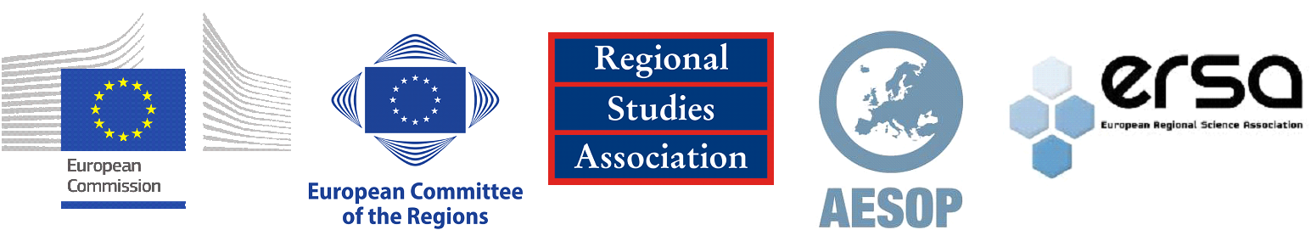

Application form

Deadline for submissions: 9th May 2018

Applications received after this date will not be accepted.

The completed application form should be combined with your CV and submitted in one document (WORD or PDF) via the online form.

I. Full name and affiliation

II. Tell us how your current research relates to European Cohesion Policy? (max. 250 words)

III. What are your future research plans? (max. 250 words)

IV. How will participation in this Master Class benefit your professional development? (max. 100 words)

V. Provide the title and outline of your paper (900- 1,000 words) here:

VI. Which Master Class theme does your paper fall under (please tick):
- Reshaping governance and institutional relations;

- Territorial cohesion and cooperation;

- Policy effectiveness in response to development challenges for European regions.

VII For early career applicants without a PhD and who are not currently PhD students, please outline here why your experience should be considered as equivalent.
Note. Applicants must be employed in a publicly funded higher education institution, research centre or similar.

VIII. Academic reference
An academic reference in support of your application must be sent separately by the referee to daniela.carl@regionalstudies.org and be received by the closing date.

Please indicate:
Name of referee
Institution
Country
Contact details of the referee (address, email address and telephone number)
Relationship to the applicant (PhD supervisor, line manager etc…)

IX. Please tick to confirm
I confirm that the information given in this form is true, complete and accurate.

The completed application form should be combined with your CV and submitted in one document (WORD or PDF) via the online form.

Please submit your application and additional documents by the 9 May 2018 15.00 (GMT) or 16.00 (CET).

For questions, please contact Daniela Carl at daniela.carl@regionalstudies.org

