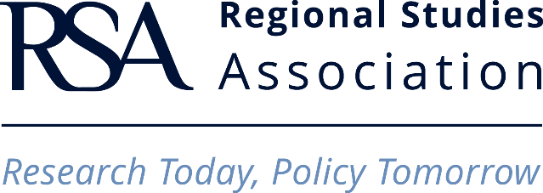

TRAVEL GRANT - CLAIM FORM

Please complete the form below and email it to: travelgrant@regionalstudies.org

Name of Travel Grant Holder
Date(s) and place of event attended
Date of Claim
Date of Submission - Event Report Form

Travel Itinerary
Car rate 40p/mile
Train, bus, coach, plane etc: lowest transport class/fare available
Taxi: Essential uses of this mode of transport must be explained – taxi fares are not routinely reimbursed.
Details of total travel costs
(£500 maximum will be reimbursed).
Have you attached copies of all your travel receipts?
Present the original tickets and attach an invoice if the price is not mentioned on the ticket itself.

Bank Transfer Form

The Regional Studies Association (RSA) can make a payment directly into your bank account. Please include full details below, to ensure that the funds are transferred to the correct account.
UK sterling bank accounts complete A to D, E and F
UK currency bank accounts complete A to D, G and H
Europe bank accounts complete A to D, G and H
USA bank accounts complete A to D, E and I
India bank accounts complete A to D, E and J or K
China bank accounts complete A to D, E, H and K
Hong Kong accounts complete A to D, E, G and H

A | Full name of Individual or Organisation
B | Address of Individual or Organisation
C | Name of Bank
D | Address of Bank
E | Bank Account Number
F | Sort Code (UK only)
G | IBAN (International bank account number)
H | SWIFT/BIC code
I | ABA Routing Number (USA only)
J | IFSC (Indian Financial System code)
K | Routing code (other local bank code)

Bank Details supplied by:
Signature*
Name
Job Title/Organisation
Any reference number to be quoted in the payment

*I hereby authorise the RSA to request information from the transport companies involved in the journeys for which I am claiming reimbursement. I understand that by signing this form I am giving my consent. I declare that the information given on this form is true and accurate and that the travel expenses I am claiming will not be reimbursed by other sources.

