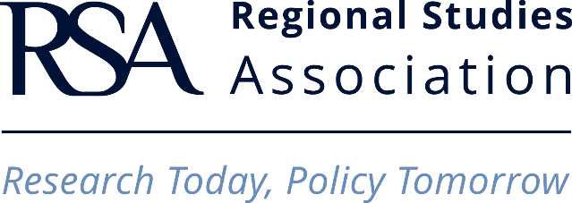

TRAVEL GRANT - APPLICATION FORM

Apply for up to £500 funding towards your travel costs (transport only) to attend a non-RSA event. This grant is an opportunity to help you towards your travel costs to present your work, network and participate at worldwide non-RSA events within the field. You must be presenting a paper at the event in the field of regional studies (sub-national).
Please complete the form below and email it to: travelgrant@regionalstudies.org

APPLICANT
Please enter your details below
Title:
Name:

Address and postcode:

Phone number:

Email address:

Affiliation:
Name and address of Higher Education Institution;
Position, Job Title

RSA MEMBERSHIP
Applicants of the travel grant must be a member of the Association at the time of the application, at the time of travel and at the point of claiming reimbursement. Non-members are encouraged to apply and join at the same time.
RSA membership number:

RSA Membership category:
Student, Early Career, Individual or Associate)

RSA Membership expiry date:

DETAILS OF THE EVENT THAT YOU WISH TO ATTEND
Please be aware that the event you wish to attend needs to be held a minimum of 4 weeks after the Travel Grant application deadline has passed.
Name of the event:
Website of the event:

Dates of the event:

Location of the event:

Summary of the event (Approximately 250 words):

YOUR PRESENTATION
Title of paper, which you plan to present at the event:
Abstract of your paper (please copy your 400-word max abstract here):

Explain how your paper is directly linked to regional studies:

Please tell us how you plan to promote the RSA and its membership:

Please add any information that would support your application (if any):

TRAVEL AND FUNDING
The RSA Travel grant only covers travel costs up to £500 (not accommodation, subsistence, conference fee and food).
Detailed planned travel itinerary:

Details of budgeted costs and contribution the grant makes to the total cost of the trip:

Names and sums given from other funding sources (if any):

Name and signature (for electronic versions):
I have read the Terms and Conditions stated in the Travel Grant Handbook and, if my application is successful, I agree to abide by them.
Date and Place:

