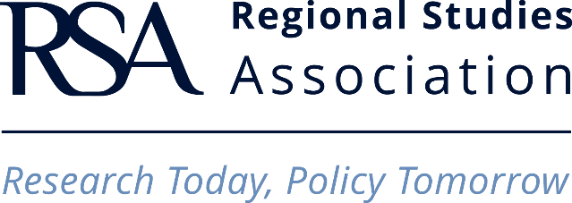

RESEARCH NETWORK GRANT SCHEME (RN)
Claim Form

Please note that the organisers of the funded events are directly responsible for the claims and for any delay in the reimbursement of expenses due to mismanagement of claims. The Association is only able to provide reimbursement once the claim forms (with attached original receipts) have been signed by and sent to the office for processing by the organisers.

EVENT TITLE

RESEARCH NETWORK TITLE

DATE AND PLACE OF EVENT

ORGANISER(S)’ NAME(S)

ARE ALL RESEARCH NETWORK ORGANISERS CURRENT RSA MEMBERS?
NAME OF CLAIMANT

EMAIL ADDRESS OF CLAIMANT

DATE OF CLAIM

I. Are you (please delete where appropriate):

An organiser a delegate

II. Are you a current member of the RSA?

Yes RSA membership ID: __ __ __ __

No If you are not a current RSA member, you cannot claim for your expenses.

III. How do you wish to be refunded? Please include full details below, to ensure that the funds are transferred to the correct account. The Regional Studies Association (RSA) can make a payment directly into your bank account.
UK sterling bank accounts complete A to D, E and F
UK currency bank accounts complete A to D, G and H
Europe bank accounts complete A to D, G and H
USA bank accounts complete A to D, E and I
India bank accounts complete A to D, E and J or K
China bank accounts complete A to D, E, H and K
Hong Kong accounts complete A to D, E, G and H

A | Full name of Claimant (Individual or Organisation)
B | Address of Individual or Organisation
C | Name of Bank
D | Address of Bank
E | Bank Account Number
F | Sort Code (UK only)
G | IBAN (International bank account number)
H | SWIFT/BIC code
I | ABA Routing Number (USA only)
J | IFSC (Indian Financial System code)
K | Routing code (other local bank code)
Signed by claimant

EXPENSES
Transport: Train, plane, ferry, bus and underground. The RSA only reimburses economy class transport and will not cover taxi costs.
Date of spending | Mode of transport | Currency of expenses | Cost in local currency | Total cost | Sum of bursary allocated

Accommodation. The RSA only reimburses single occupancy rooms
Date of spending | Currency of expenses | Cost in local currency | Total cost | Sum of bursary allocated

Other. (According to the Research Networks Guidelines)
Item to be covered | Currency of expenses | Cost in local currency | Total cost | Sum of bursary allocated
Please do not convert currencies used into GBP as this will done when the reimbursements take place. The exchange rate will be the one rated on the day of reimbursement.

I, one of the organisers of this event authorises this claim to be refunded to the delegate via our RSA Event Funding Scheme money.

Name of organiser or person responsible for all claims:

Signature of organiser or person responsible for all claims:

If this form is not signed by an organiser or the named person responsible for event, the refunds will not be allowed by the RSA. Please make sure that all ORIGINAL receipts are attached to this form otherwise the Association will not be able to provide refunds.

Please note, the RSA will reimburse the Research Network on production by the Research Network of evidence that all conditions of the grant have been fulfilled. This may include (but is not limited to) the production of event report forms, photographs and delegates lists of events, evidence of dissemination of RSA marketing materials and presentations during the event. Please consult the guidelines for more information.

Return the signed form to:

Regional Studies Association
Sussex Innovation Centre, Falmer Brighton BN1 9SB, United Kingdom
Email: researchnetwork@regionalstudies.org
tel: +44 (0)1273 698 017

