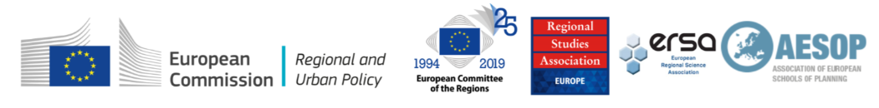

EUROPEAN WEEK OF REGIONS AND CITIES 2019
7th Master Class on EU Cohesion Policy
Application form
Deadline for submissions: 1st May 2019

Applications received after this date will not be accepted.

The completed application form should be combined with your CV and submitted in one document (WORD or PDF) via the online form (Google form).

I. Full name, affiliation and email address

II. Tell us how your current research relates to European Cohesion Policy? (max. 250 words)

III. What are your future research plans? (max. 250 words)

IV. How will participation in this Master Class benefit your professional development? (max. 100 words)

V. Provide the title and outline of your paper (500 words excluding references) here:

VI. Which EU Regions Week and Master Class theme does your paper fall under (please tick):
- The Future of the EU and the roles of the Regions and Cities
#EUBudget
#Cohesion
#Post2020
#ERDF
#Subsidiarity
#Democracy
#Demography
#InternationalCompetition
#Digitalization

- A Europe Closer to Citizens
#TerritorialCohesion
#Cooperation
#People
#Places
#Urban
#Rural
#LocalCommunities
#Migration
#AdministrativeCapacity

- A Greener Europe
#EnergyTransition
#ClimateChangeAdaptation
#CircularEconomy
#RiskManagement
#EuropeanSolidarityFund

VII For early career applicants without a PhD and who are not currently PhD students, please outline here why your experience should be considered as equivalent. Note. Applicants must be employed in a publicly funded higher education institution, research centre or similar.

VIII. Academic reference
An academic reference in support of your application must be sent separately by the referee to Klara Sobekova at office@rsaeurope.org and be received by the closing date.

Please indicate:
Name of referee
Institution
Country
Contact details of the referee (address, email address and telephone number)
Relationship to the applicant (PhD supervisor, line manager etc…)

IX. Please tick to confirm
I confirm that the information given in this form is true, complete and accurate.
The completed application form should be combined with your CV and submitted in one document (WORD or PDF) via the online form.

Please submit your application and additional documents by the 1st May 2019 15.00 (GMT) or 16.00 (CET). For questions, please contact Klara Sobekova at office@rsaeurope.org.

As part of the application process, your details will be provided to the selection committee. Please see the RSA’s Privacy Statement at www.regionalstudies.org/privacy

