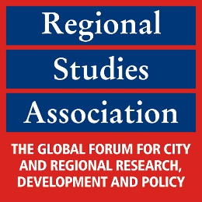
RSA Annual Conference 2019
pushing regions beyond their borders
5th June – 7th June 2019
University de Santiago de Compostela, Santiago de Compostela, Spain
Deadline for Special Session proposal submissions: 4th January 2019
CALL FOR SPECIAL SESSION PROPOSALS

As part of the 2019 Annual Conference, we welcome proposals for Special Sessions. Special Sessions are a great way to bring together presenters to discuss and highlight a particular topic and to develop or further extend your network.

We offer two types of Special Sessions:
- Open Special Session – the session organiser proposes the topic and provides a short description/ call for submissions (please use headers below). Delegates can submit their abstract for this session when they register for the conference.

- Closed Session – the session organiser proposes the complete session including all speakers. Other delegates may not submit their abstracts for this session. Please note that all speakers need to register to be able to present.

Both sessions are open to all delegates to attend as audience.

Once your Special Session proposal has been accepted, we will add it to the conference’s page and promote it. As the session’s organiser, we would be grateful if you could also spread the word to interested researchers via your networks.

After the general abstract submission deadline has closed (28th February 2019), you will receive all abstracts submitted to your session for your review.

After reviewing the abstracts, the next step will be to send the accepted abstracts in the order you wish to have them in your Special Session to the RSA. The actual scheduling of the programme will then be done by the RSA.

Contact

If you would like to organise a Special Session, please complete the headings below and send to Lesa Reynolds at lesa.reynolds@regionalstudies.org.

Session Title:

Session Organiser:

Open/Closed Session:

Description (with speakers listed if a closed session):

